Summary:
Working on a Blockchain application that caters towards the transparent interaction between the farmers and the end consumers through an independent governing body.

Objectives:

- Efficient Supply Chains in Developed Economies

Possibly the highest potential for blockchain in agriculture is in the developed world, where it can be very helpful in monitoring the supply chain of food products.

- Product tracking
By providing both parties with access to information on similar transactions, as well as on the current stock price of goods, even suppliers in rural areas are able to determine what their harvest is currently worth and sell it to distributors at a price that reflects global market conditions.
- Tracing origin
By establishing a blockchain-driven ecosystem for the registration, payment, and transport of crops or other agricultural products, retailers can also verify easily that the product they are receiving is exactly what they paid for
- Fair pricing and decreased transaction fees
Blockchain can provide an easy solution for both buyers and suppliers seeking to negotiate a fair price for their product.
- Minimizing Human Error
Blockchain can also be used to minimize physical and financial losses in the agricultural sector caused by human errors.
- Management transparent transactions
Blockchain enables both small farm firms and agricultural concerns to be able to keep track of their transactions to maintain accountability
- Efficient financing
But also financial transactions between farmers and buyers, that are nowadays hugely inefficient, could be improved thanks to blockchain technology.

- Smart farm contracts
Provision of agricultural services linked to conditions and rules that could be specified in the blockchain, fulfillment of which is verified via the technology platform
- Land registry
Record land ownership in the country
- The concept of Smart Farms & Data Monitoring

Wireless sensors can be integrated into fields to monitor crop growth, harvesting, and subsequent yield, with all of the data recorded onto the blockchain which further allows farmers to capture data in real-time.

- BlockChain Technology used

- ETHEREUM

- Ethereum is a public Blockchain-based distributed computing platform, featuring smart contract functionality. It provides a decentralized virtual machine, the Ethereum Virtual Machine (EVM), that can execute peer-to-peer contracts using a cryptocurrency called ether.

- How can we embed ethereum in our system?

Smart Contracts are a major part of Ethereum. Smart contracts are applications with a state stored in the blockchain. They can facilitate, verify, or enforce the negotiation or performance of a contract. Ethereum contracts can be implemented in various Turing complete scripting languages. The Ethereum system has been described by the New York Times as "a single shared computer that is run by the network of users and on which resources are parceled out and paid for by Ether."
The Ethereum platform has multiple proposed uses concerning smart contracts. Bloomberg Businessweek describes it as "shared software that can be used by all but is tamperproof."
Higher-level software can utilize Ethereum to establish an online marketplace platform.

THE ACTORS involved and their Characteristics

Before, seeing how the process actually works, it is necessary to see the actors involved in the entire transaction and the new concepts provided to it.

Actors:

1) Farmers
2) Consumers
3) Independent Data Collection Department(IDC)
- Independent Data Collector( IDC-F ) -Farmers
- Independent Data Collector(IDC-C) - Consumers

Farmers:

- ⦁ To maintain scalability, we considered to divide areas into small cluster of regions
- ⦁ Individual Farmer Association's(FA) will be registered for individual regions such that each regions has one FA in it.
- ⦁ Such Associations will collectively work on different set of issues faced by the farmers, some of the very few examples are,

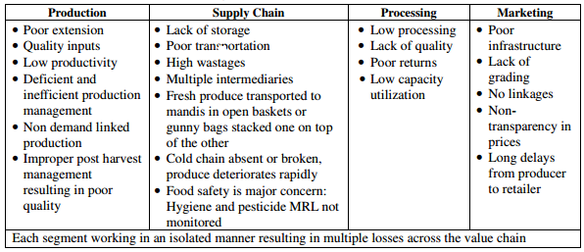

- Insufficient resources for land maintenance-
Farming technologies have become expensive and for a farmer to afford is quite a task as it requires huge tons of debt.
Sharing resources in such single associations makes the life of farmers easy.

- Expensive Fertilizers-
Farmers are given fertilizers by multinational companies for testing and using on crops, the short term affect being good, the long term affects are the degradation of quality of such crops
Making natural fertilizers by dumping wastes can prove to be more economical and preserves the quality of such crops.

- Land size harvest dependability-
Some farmers have acres of land which is difficult to manage while harvesting,
Land sharing between farmers can prove to be a faster and efficient way of harvesting.

Independent Data Collection Department (IDC)

This is the governing and trusted authority between the Farmers and the Consumers.
The IDC governs both the Farmers and the consumers by independently deploying placing Data Collectors, such as

Independent Data Collection Department

IDC-Farmers
IDC- Consumers

The privileges given to the IDC are given as follows,
    - Creating “Unique Identification Card” (UIC)
    - Validating and Verification of Cards
    - Creating database from farmers and Consumers
    - Managing the database

1.Unique Identification Number” Cards (UIN)
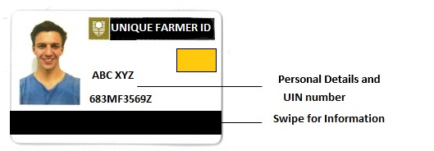

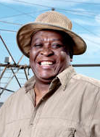

The Unique Identification Card will have information as :
- Basic information about the farmer
- Database about the crops that are grown on his land, The total harvest, Selling price, quality, processing etc
- Areas where Such Unique Identification Cards will integrate and help Farmers.

- Beneficiary identification,
- Addressing diversions and leakages
- Managing foodgrain storage and ensuring timely distribution
- Effective accountability and monitoring, and enabling community monitoring
- Mechanisms for grievance redressal
- Ensuring food security

- A role of such Cards which will help in our system.
- One beneficiary:
A unique number, unique information about the farmer and no other farmer can have a duplicate number since it is linked to their individual bio metrics.

- Land Registration:
Recording Land Registration by every Farmer on the IDC system.

- Portability in identification:
We would provide a universal number, and agencies and services
can contact the central Unique Identification database from anywhere in the country to confirm a beneficiary’s identity.

- Card authentication to confirm entitlement delivered to the
beneficiary:
Such Cards enables remote, online bio metric and demographic
Authentication of identity. Such Card-based authentication can take place in real time, and can even be performed through a mobile phone.

- Card-based authentication to track foodgrain movement:
Card-based authentication can be implemented across the supply chain, which will enable governments to track foodgrain as it is exchanged between intermediaries.

- Card-enabled cloud-computing infrastructure:
The use of Card-based authentication across the supply chain gives governments the opportunity to link such
authentication to a cloud-based management information system

- Electronic Order Management
This would enable farmers to take online orders such Unique Identification will be linked to E-Wallets for easy money transfers

Consumers

- Since to make the entire process transparent, the consumers too will be registered on the Biometric Unique Identification Cards where different transperancy will be solved.

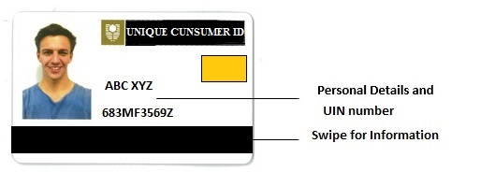

- These cards will be further divided into different levels based on the annual income generated which enables us to provide subsidized food for such people.
- This cards will be linked to the E-Wallets which provides a medium for transaction between farmers and the consumers.
- The UIC will cater the following

- Clear identification of beneficiaries:
Since we guarantee uniqueness, linking each beneficiary listed into their E-wallets and UID
would ensure that only unique individuals are present in the IDC database.

- Ensuring inclusion of the poor:
Savings from eliminating duplicates and fakes
through Card-based identification will enable governments to expand benefits to
more poor residents.

- Enabling individual entitlements:
Linking UIC to such consumers enables the IDC to provide individual, rather than household entitlements. This would make allocations more transparent, and also addresses the challenge of larger households receiving insufficient foodgrain.

The IDC Authentication
The proposed IDC provides such advantages when it comes to authentication
- Ensuring zero proxy withdrawals:
A key source of leakage identified in the conventional models, is subsidized food
drawn from the farmers in the names of Below Poverty Line eligible families by someone else.

- Card-based authentication across the supply chain
Implementing IDC authentication at every exchange point would enable us to track the movement of food entitlements across the system supply chain, and identify bottlenecks and diversions in real-time.

- Accountability in foodgrain movement
The use of IDC at subsidy exchange points would ensure that the responsibility of each individual – supplier, transporter, FPS owner, inspector – is traceable, and clearly visible across the IDC infrastructure.

- SMS alerts:
An SMS-alert can be sent to the resident’s UDI-linked mobile number,
when the truck leaves from the warehouse for the delivery. The SMS can contain
information such as time the truck left, quantity of grain it is carrying, and grain prices.

- Making information public
An system across such infrastructure means that
data would be easily accessible across the supply chain. This information can be shared
by the IDC with beneficiaries.

Distribution channels

- Via APP
- As every customer have a unique identification card issued from an trusted authority.
- The customers that can afford to have a smart phone can make their online food account corresponding to their unique identification card on an APP.
- Every person can then order products they want from their food account through the APP.
- The APP would consist of an e-wallet with digital currency as ETHER and pay their bill using this e-wallet.
- The order they make is managed by the IDC of farmers where IDC-F contacts the farmers association and inform about the order that each farmer has.
- Farmers then move their products to a ware house using a transportation system and then to end consumers in the city .

- Via IDC-C
- Consumers that are below poverty line cannot afford a smart phone and hence cannot manage their food account on their own.
- For this purpose, people below poverty line uses their UID cards to order food via IDC-C on monthly basis.
- IDC-C can manage every user account and order food after some validations such as limits of ordering an item’s quantity does not exceed the specified limit and corresponding ether is available in their account to pay the bill.
- IDC-C then groups the order of various consumers and sends this to IDC-F.
- IDC-F then contacts the farmers association and inform farmers about the order that they need to deliver.
- Farmers then transport the items to distribution center directly as they need to deliver it once in a month.
- Consumers can collect their items from distribution center.

Internet of things(IOT)

Internet of Things (IoT), It provides services that goes beyond Machine-2-Machine communication. Wide variety of device will be used for monitoring and providing real time information.
Data provided by the devices will be in real time hence providing a effective pattern solving tool.
Real time database will be stored in Cloud, it can be accessed by anyone and anywhere.

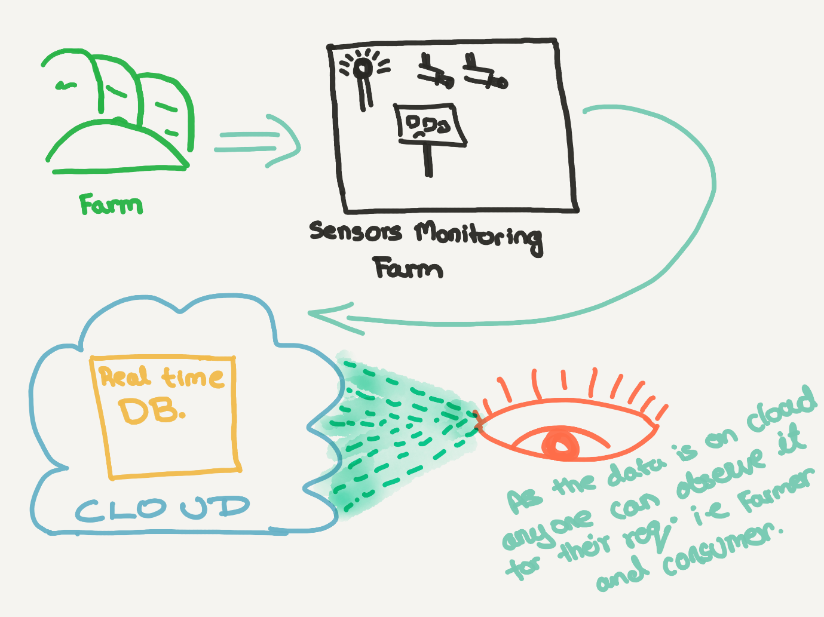

Working:

- Farms will have sensors installed in them
- These sensors will feed data into the database
- Database will be in Real Time, i.e. the information will be updated into the database as soon as the sensors feeds the data.
- The Database is stores in the cloud, hence it can be accessed by anyone (i.e. consumers and farmers).
- This will bring a transparency in the quality of food and the consumers will know the environment of the product that they will receive.

Pros:
For farmers,
- Soil Water Level
- Fertilizer level
- Temperature of soil
- Temperature of surrounding
- Wind Speed
- These factors will help a framer to provide a better treatment to grow their products hence effecting the quality of the product.
- Good Capacity Utilization
- Good Returns
- High Processing
Cons:
- Sensors need to be maintained for the accuracy.
- As, the data is stored in cloud it is vulnerable from the attacks of hackers, but it should not be an issue as the data is feeds in real time hence it is updated on regular intervals.

Fulfilling food security goals

- The IDC system can host online food accounts on the cloud, which are
linked to UID numbers of farmers as well as each individual beneficiary.
- The online account of the beneficiary would be updated monthly with the details of
their entitlements – which foodgrains, how much, and at what price
- When the beneficiary authenticates themselves with their UID to collect
the benefit, the authentication confirmation appears against the owner’s food
account. The system can thus track offtakes of foodgrain in real-time.

Incentives for Consumers
- Ease in identity verification
With UID,consumers can easily establish their identity, wherever they are in the country.

- Expanded coverage
Ease in identity verification will allow poor consumers who have so far been shut out of food subsidies, to access food entitlements.

- Improved services through increased transparency:
Clear accountability and transparent monitoring would significantly improve access and quality of entitlements to beneficiaries.

Etherium integration on app

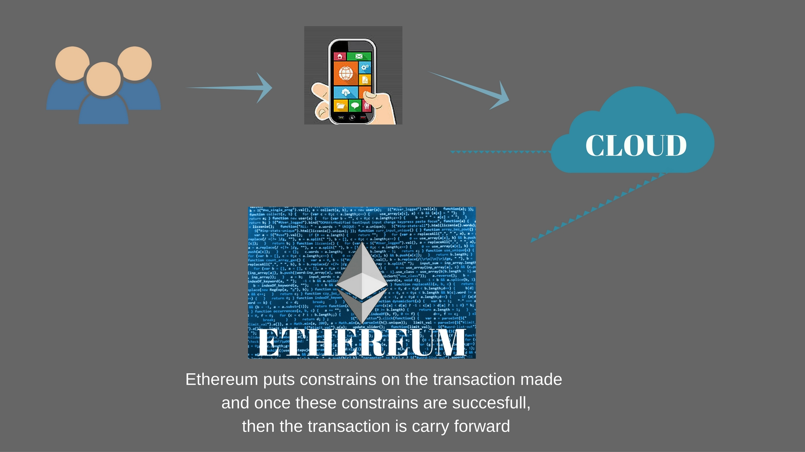

THANK YOU

