Contents
Introduction 2
Aim 2
Objective 2
Functionalities of application 3
Explanation on functionalities 5 – 8 4
System design 5
Technical Description 6
Benefit to User 6
Future Development 7
Conclusion 7
References 8

Introduction
Blockchain technology is a public ledger that is shared and trusted by everyone in which the participant of the technology is responsible to keep the ledger to be up to date. This public ledger is not owned by a single entity namely a company or an individual but distributed across the network. Every person on the network has the access to the ledger but has no control to modify any of the record in the ledger. (BBC Corporation, 2016) To think about the blockchain technology in a technical term, blockchain is a data structure or a way to store data instead of the conventional way of storing data in a centralized database. Each block hold a set of data, which chained to the previous block by some value. (Tapscott, 2016)
Upon knowing the underlying principle of blockchain technology, some of the important properties of blockchain surface that indicate the blockchain is secured and proved to be impossible for a security bleach. Using the properties of blockchain technology as decentralized and secure storage, the belief to develop a sport coaching services using blockchain technology is known. This web application uses the blockchain technology as the foundation as the mean to handle how a client employ sport coaching services. In this application, any pieces of data such as user profile, services booking information and transaction information can be stored in the network as a block. This application can be used by clients to sign up for any coaching services. That is, clients can apply for the services provided by any registered coach and perform booking in any facilities.

Aim
The aim of the project is to develop a web application that provide sport coaching services using blockchain technology. Through the secure and decentralized properties of blockchain technology, the web application developed is aimed to be safe, protected and fraud-free solution to be applied on sport coaching services. On top of that, the web application would provide a platform for sport coaches to involve in entrepreneurship.

Objective
The objective of this project is shown as below.
- To implement sport coaching services as a web application.
- To integrate blockchain technology to the web application as the storage of all the transaction.
- To enhance the security aspect of the web application as a safe and secure solution.
- To demonstrate the usability of the web application as a short video.

Functionalities of application
- The application serves for coach and client as the user.
- The application allows coach and client to register to the system and publish the profile to any user.
- The application allows coach and client to log into the system to use the feature.
- The application allows client to view sport coaches.
- The application allows client to select any coaches of a particular sport for coaching services. Alternatively, the application allows client to select any entity that declared to give coaching services.
- The application allows client to select the period for coaching services in a table format.
- The application allows coaches to declare him or herself to be an entity that provide coaching services to the client, which under this entity, the coach can employ other coaches to participate in the services. The coach here is term “employer”.
- The application allows that any coach that employed by other coaches to be part of the services providing to the client. This mean that the employing coach can assign any coaching services of client to coaches employed.
- The application allows coaches to check on the schedule in a table format.
- The application allows client to pay for coaching services using bitcoin. The client can top up bitcoin using online banking.
- The application allows client to view the schedule.
- The application allows client to postpone coaching services on another later date.
- The application allows client to view history including coaching service history and transaction history.
- The application allows both client and coach to change profile information. For coach that had declared to be an entity, only certain information can be changed.

Explanation on functionalities 5 – 8
Suppose that there are 5 registered coaches currently in the system. Coach 1 can make the entity as the name “Ryan coaching services provider” (etc.) and then this entity can employ other coaches, like coach 2, 3,4 or 5 to be under this entity. So this entity is essentially like a company that can recruit other coach. When client want to use the coaching services, the request is fall under this entity, not by the coach 2, 3, 4 or 5 that is employed under “Ryan coaching services provider”. The application will then pass the request to coach 1 since he is the employer. The request notify coach 1 that the client want to use the services of this entity that the coach selected is coach 3 (just an example, the client can choose other coach, coach 2, 4 or 5). Coach 1 can then assign the coach and if the coach is assigned to other client, coach 1 can reassign the original client to other employed coach.

System design
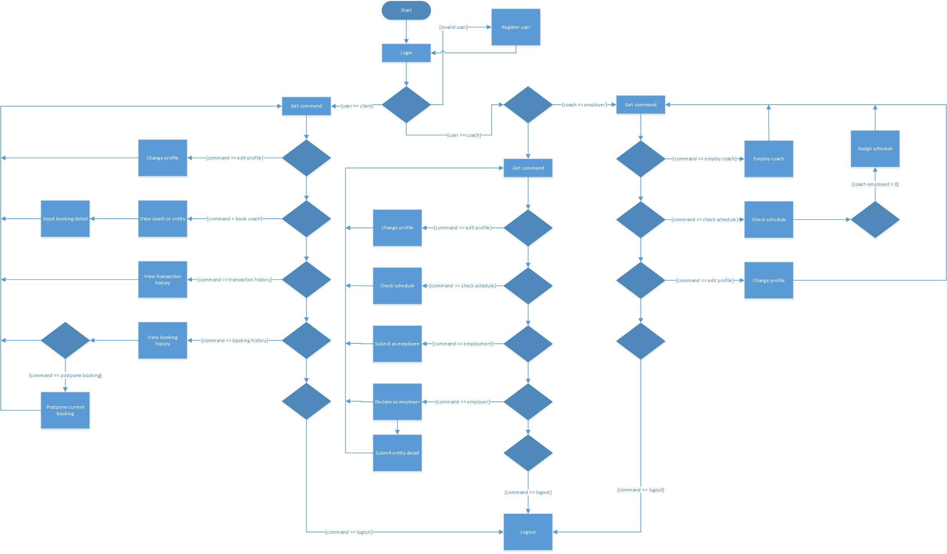

Technical Description
The proposed application will be a distributed app (or dapp) built on top of the Ethereum blockchain app platform. The application can be written for various platforms, including web and mobile applications. As a dapp, the application stores its data on the Ethereum blockchain and is powered by computing power from Ethereum miners.
The dapp consists of a frontend that users will interact with, and is no different than any other web application. The backend of the dapp is made up of code running on the Ethereum blockchain, or contract. The code will run and be validated by all nodes on the Ethereum network, ensuring that the backend does exactly as the code says.
The hardware required for using the application is any device capable of accessing web applications through a browser.

Benefit to User
- Bitcoin transaction does not required to be processed during working hour, it is available in 24/7.
- Bitcoin transaction reduces transaction fee as it does not go through third party service.
- Data is more secured as no third party server involved in system.
- Every entity is able to access the system that includes client, coach and employee.
- Easy to access web application that does not require high-end hardware.

Future Development
The final application will be enhanced and integrated that meets consumer needs. One of the future development as planned is increase in position for entity. As current application has only Client, Coach and Employee that will create limitation to other users such as Master and Court Manager. Master will be able to access all user’s credential and edit them if necessary. Court Manager will be able to control the availability, number, and price of court as the system has integrated. As more entity position has added into the system, the work will be distributed to other perspective entities and more employee will be able to handle the system.
As the system is less known to the public who are interested in sporting culture, the next future development will create feedback system, forum and more social media increment. Feedback system enables user to give suggestion and improvement to the current proposed application. Forum and social media allows user to get updates from our system and enhance sporting bond not just from system to user but also from user to user. This will allow more user to have interest in not just sport, but more to social media.

Conclusion
When technology is evolving from time to time, this sport coaching web application is a blast that fits every user needs. It has more functionality than the other web application. Client can perform various task from view personal information to select a particular coach to ensure that client does not make wrong decision. This web application is built to be safe and ensure user will not forget about it. It also consists of more security integrity as known as Blockchain to help store data in a decentralized method. With the help of Blockchain, data will not leaked out to the other parties but only user can access to it. As long as Blockchain is here to serve our web application, user is carefree to forget about losing their vital data that stored in system.

References
BBC Corporation, 2016. How blockchain tech could change the way we do business. [Online]
Available at: http://www.bbc.com/news/business-35370304
[Accessed 12 November 2016].
Tapscott, D., 2016. How the blockchain is changing money and business. s.l.: TED.

